CS584 Assignment 4

Weilun Zhao; A20329942

# 1. Data generate:

2D feature vector of two classes; totally having 100 number of data;

## Linearly separable:

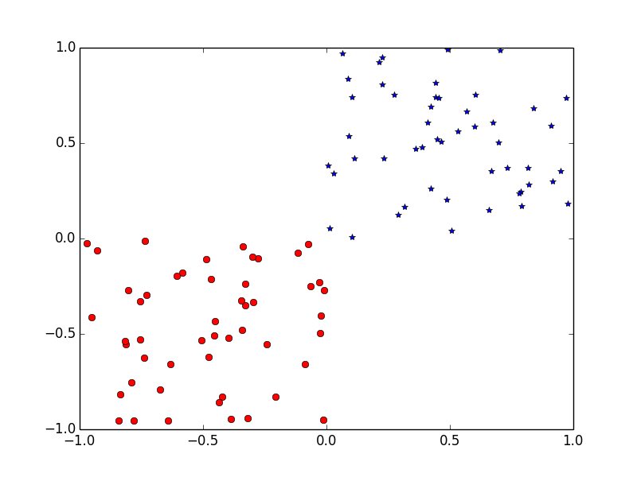

## non-Linearly separable

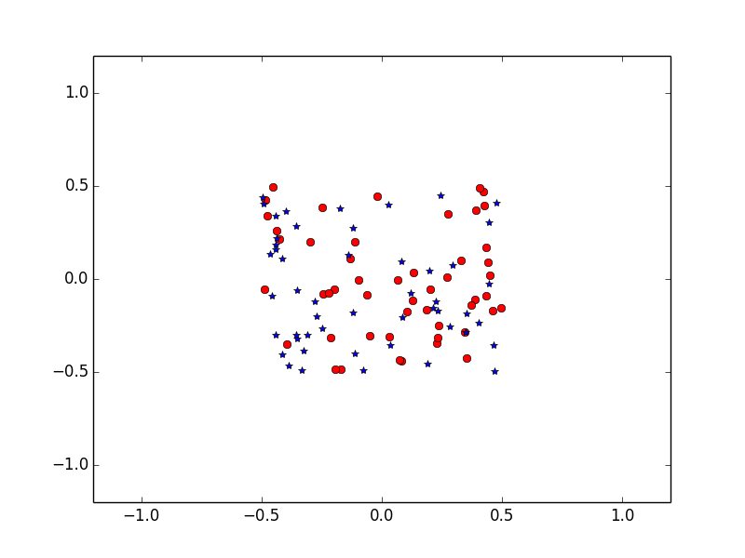

# 2. hard margin SVM

## Linearly Separable

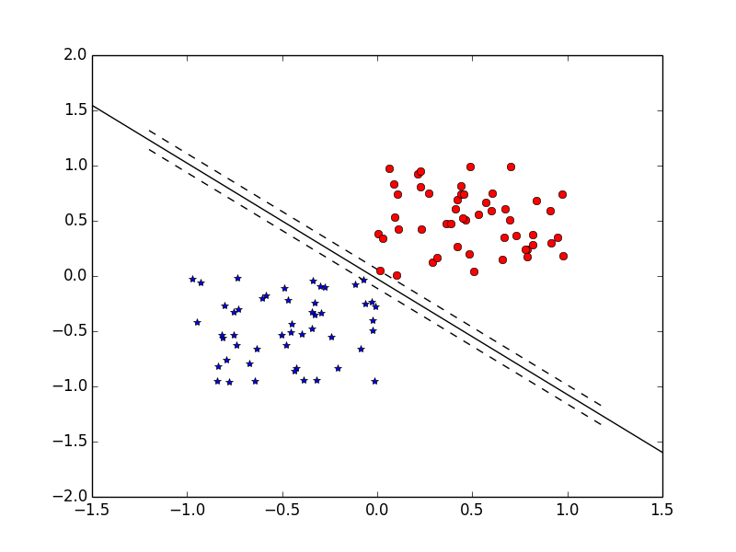

## Two hand Cross Validation in Linearly Separable

|  |  |  |
| --- | --- | --- |
|  | Cross 1 | Cross 2 |
| Plot data graph | ../figure_CrossVal1.png | ../figure_CrossVal2.png |
| Performance | | |
| Confusion matrix | [[25 0]  [ 0 25]] | [[25 0]  [ 1 24]] |
| Accuracy | 1.0 | 0.98 |
| Precision | 1.0 | 0.961538461538 |
| Recall | 1.0 | 1.0 |
| Fmeasure | 1.0 | 0.980392156863 |
| Total Performance | | |
| Accuracy | 0.99 | |
| Precision | 0.98 | |
| Recall | 1.0 | |
| Fmeasure | 0.989898989899 | |

## Non Linearly Separable

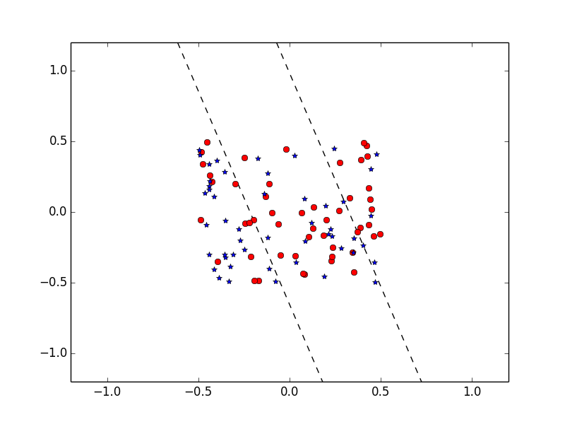

## Two hand Cross Validation in Non Linearly Separable

|  |  |  |
| --- | --- | --- |
|  | Cross 1 | Cross 2 |
| Plot data graph | ../NolinearSep/CrossValNoSep1.png | ../NolinearSep/CrossValNoSep2.png |
| Performance | | |
| Confusion matrix | [[13 12]  [10 15]] | [[17 8]  [13 12]] |
| Accuracy | 0.56 | 0.58 |
| Precision | 0.565217391304 | 0.566666666667 |
| Recall | 0.52 | 0.68 |
| Fmeasure | 0.541666666667 | 0.618181818182 |
| Total Performance | | |
| Accuracy | 0.618181818182 | |
| Precision | 0.6 | |
| Recall | 0.566037735849 | |
| Fmeasure | 0.582524271845 | |

# 3. Soft margins SVM:

soft margins definition:

$$y^{\left(i\right)}\left(W^{T}X^{\left(i\right)}+w_{0}\right)> 1-ξ_{i}$$

$ξ_{i}$ is slack variables;

Based on the formula in the question 3:

$$\left\{\begin{aligned}\min{L_{P}}=\frac{1}{2}W^{T}W+c\sum_{i=1}^{m}{ξ_{i}}-\sum_{i=1}^{m}{α_{i}\left(y^{\left(i\right)}\left(W^{T}x_{i}+w_{0}\right)-1+ξ_{i}\right)}-\sum_{i=1}^{m}{{β_{i}ξ}_{i}} \\ s.t. { ξ}_{i}>0; \end{aligned}\right.$$

We want to using partial derivative to get $\min{L_{P}}$; $\frac{∂L_{P}}{∂W}=0; \frac{∂L_{P}}{∂w_{0}}=0; \frac{∂L_{P}}{∂{ ξ}_{i}}=0$

$$\frac{∂L_{P}}{∂W}=\frac{1}{2}*2∙W-\sum_{i=1}^{m}{α_{i}\left(y^{\left(i\right)}x^{\left(i\right)}\right)}=0$$

$$\frac{∂L_{P}}{∂w_{0}}=-\sum_{i=1}^{m}{α_{i}\left(y^{\left(i\right)}\right)}=0$$

$$\frac{∂L_{P}}{∂{ ξ}_{i}}=-\sum_{i=1}^{m}{α_{i}}+cm-\sum_{i=1}^{m}{β_{i}}=0$$

I can get:

$W=\sum_{i=1}^{m}{α_{i}\left(y^{\left(i\right)}x^{\left(i\right)}\right)}$ and put W into $L_{P}$ then get the result of $L_{D}$

$$L_{P}=\frac{1}{2}{\sum_{i=1}^{m}{α_{i}\left(y^{\left(i\right)}x^{\left(i\right)}\right)}}^{T}\sum_{i=1}^{m}{α_{i}\left(y^{\left(i\right)}x^{\left(i\right)}\right)}+c\sum_{i=1}^{m}{ξ_{i}}-\sum_{i=1}^{m}{α_{i}\left(y^{\left(i\right)}\left({\sum_{i=1}^{m}{α_{i}\left(y^{\left(i\right)}x^{\left(i\right)}\right)}}^{T}x_{i}+w_{0}\right)-1+ξ_{i}\right)}-\sum_{i=1}^{m}{{β_{i}ξ}_{i}}$$

$$L_{D}= -\frac{1}{2}\sum_{i=1}^{m}{\sum_{j=1}^{m}{α_{i}α_{j}y^{\left(i\right)}y^{\left(j\right)}{x^{\left(i\right)}}^{T}x^{\left(j\right)}}}+\sum_{i=1}^{m}{α_{i}}$$

# 4. Implement Soft margins SVM

## Soft margins with Linearly separable dataset

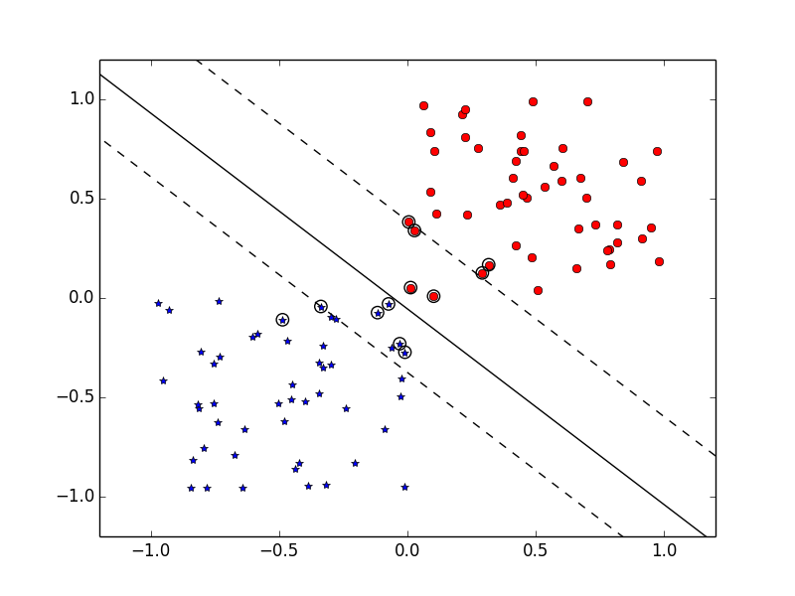

## Soft margins with Non Linearly separable dataset

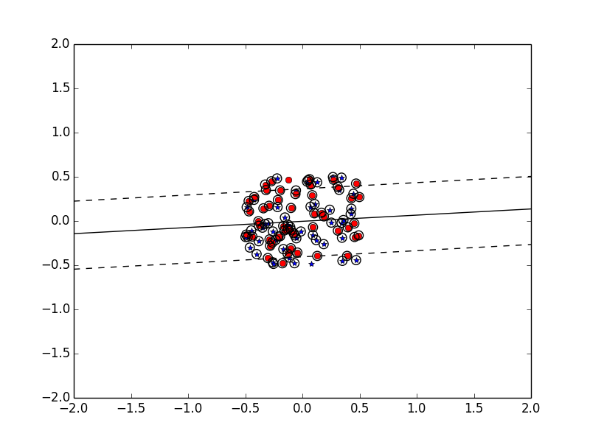

# 5. Implement Kernel-based SVM

## Kernel based SVM

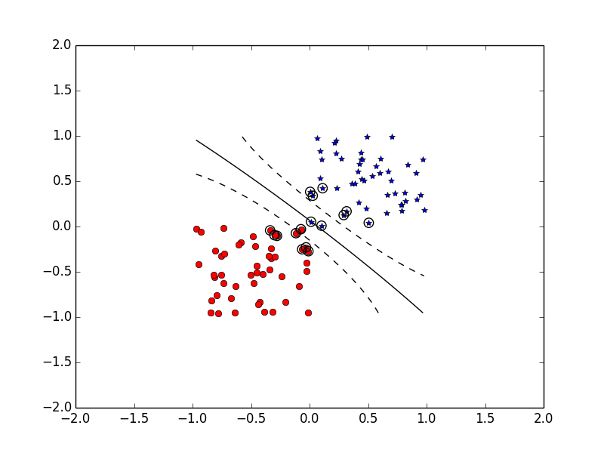

## Two hand Cross Validation

|  |  |  |
| --- | --- | --- |
|  | Cross 1 | Cross 2 |
| Plot data graph | ../KernelCross/KernalCrossVal2_1.png | ../KernelCross/KernalCrossVal2_2.png |
| Performance | | |
| Confusion matrix | [[25 0]  [ 0 24]] | [[24 1]  [ 0 25]] |
| Accuracy | 1.0 | 0.98 |
| Precision | 1.0 | 1.0 |
| Recall | 1.0 | 0.96 |
| Fmeasure | 1.0 | 0.979591836735 |
| Total Performance | | |
| Accuracy | 0.99 | |
| Precision | 1.0 | |
| Recall | 0.98 | |
| Fmeasure | 0.989898989899 | |

## External Dataset

### Circle dataset:

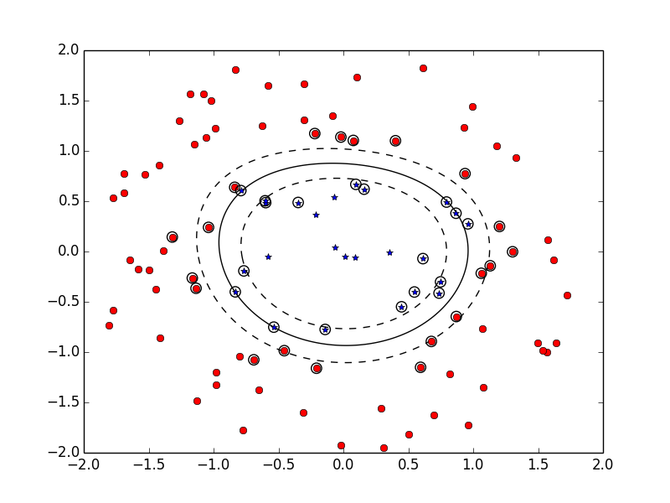

### Two hand cross validation

|  |  |  |
| --- | --- | --- |
|  | Cross 1 | Cross 2 |
| Plot data graph | ../KernelCross/KernalCrossVal1.png | ../KernelCross/KernalCrossVal2.png |
| Performance | | |
| Confusion matrix | [[12 0]  [ 4 34]] | [[ 6 7]  [ 0 37]] |
| Accuracy | 0.92 | 0.86 |
| Precision | 0.75 | 1.0 |
| Recall | 1.0 | 0.461538461538 |
| Fmeasure | 0.857142857143 | 0.631578947368 |
| Total Performance | | |
| Accuracy | 0.89 | |
| Precision | 0.818181818182 | |
| Recall | 0.72 | |
| Fmeasure | 0.765957446809 | |

### Non Linear Separable Dataset

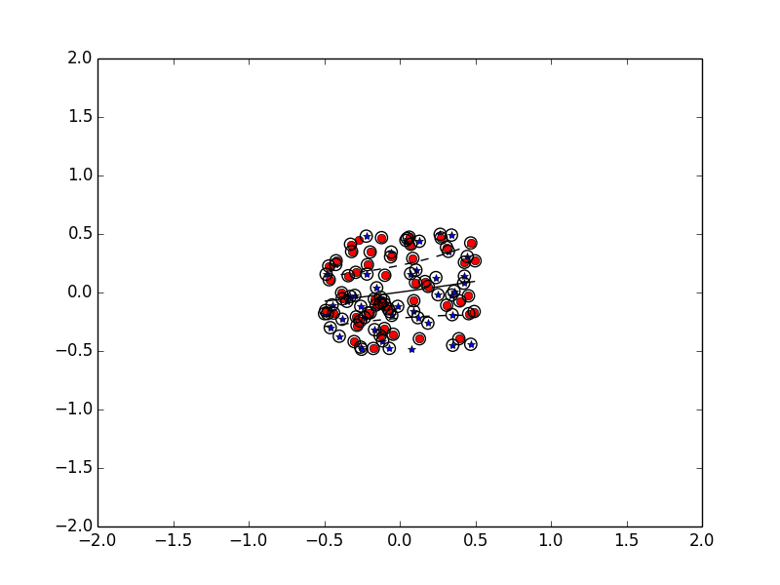

### Two hand cross validation

|  |  |  |
| --- | --- | --- |
|  | Cross 1 | Cross 2 |
| Plot data graph | ../KernelCross/KernelNonlinearCrossVal1.png | ../KernelCross/KernelNonlinearCrossVal2.png |
| Performance | | |
| Confusion matrix | [[13 12]  [10 15]] | [[19 6]  [15 10]] |
| Accuracy | 0.56 | 0.58 |
| Precision | 0.565217391304 | 0.558823529412 |
| Recall | 0.52 | 0.76 |
| Fmeasure | 0.541666666667 | 0.64406779661 |
| Total Performance | | |
| Accuracy | 0.565656565657 | |
| Precision | 0.553571428571 | |
| Recall | 0.632653061224 | |
| Fmeasure | 0.5904761904766 | |

Explanation: Kernel-based SVM is way to classified dataset which is non linearly separable.

In addition, using kernel trick to solve high dimension feature is more efficient.

# 6. Testing one class which has substantially more example

## Using Kernel dataset

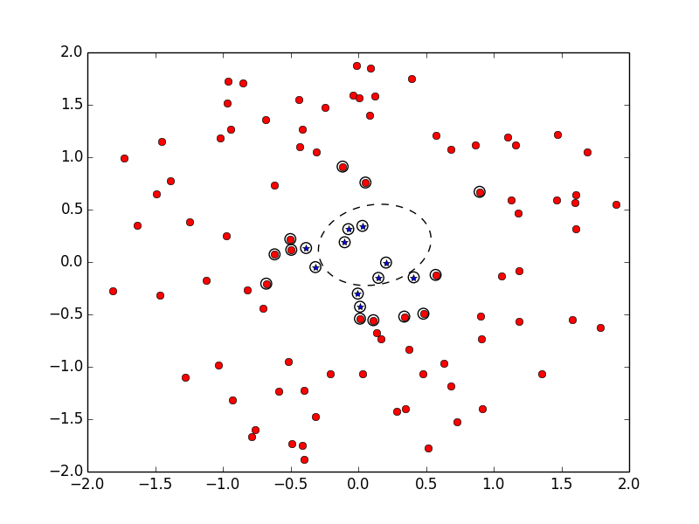

## two hand cross validation

|  |  |  |
| --- | --- | --- |
|  | Cross 1 | Cross 2 |
| Plot data graph | ../KernelCross/SubKer_6/Sub_cross1.png | ../KernelCross/SubKer_6/Sub_cross2.png |
| Performance | | |
| Confusion matrix | [[ 4 0]  [ 3 43]] | [[ 0 6]  [ 0 44]] |
| Accuracy | 0.94 | 0.88 |
| Precision | 0.571428571429 | 0 |
| Recall | 1.0 | 0 |
| Fmeasure | 0.727272727273 | 0 |
| Total Performance | | |
| Accuracy | 0.91 | |
| Precision | 0.571428571429 | |
| Recall | 0.4 | |
| Fmeasure | 0.470588235294 | |

Explanation: If one class has substantially more examples, the SVM has a tendency to evaluate the test data with this class feature. The class with substantially more examples influents the weight of feature and decrease other class data evaluation.